**China's Socioeconomic and Environmental Indicators: An In-depth Analysis**

Name:

Student ID:

Repo_link:

China, also known as People’s Republic of China, is a country located in East Asia with a population of over 1.4 billion people. It is known for its rich history, diverse culture, and rapid economic growth.

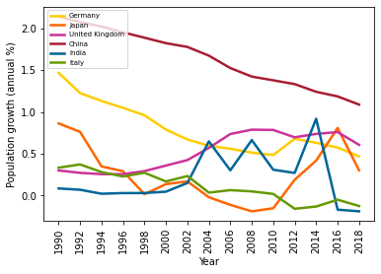

*Fig 1: Population growth % of Countries from 1990-2020*

The graph above shows the annual population growth percentage for different developing countries from 1990 to 2020. It is clear that China has the highest population growth during this time. Although there is a steady decline in the curve it still remains as the country with the highest percentage of population when compared to the other major countries. Due to overpopulation, there have been adverse effects like pollution, deforestation, per capita emissions, etc.

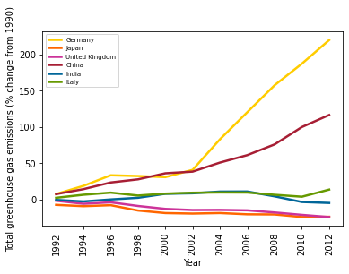

*Fig 2: Total greenhouse gas emissions of different Countries from 1990-2020*

The second graph shows the Total greenhouse gas emissions of different Countries from 1990-2020. Although Germany shows the highest amount of emissions China stands second. It can be deduced that the large population has led to industrialization, deforestation, consumption patterns and increased energy demand which led to these greenhouse gas emissions.

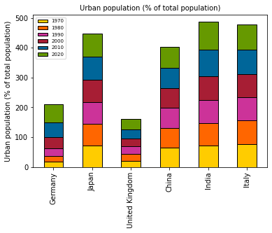

*Fig 3: Urban population growth % from 1970-2020*

Urbanization was one of the effects of high population growth. The need for employment and better living situations has led to this major change. We can observe from the above graph that China has had a steady urban population % throughout the years.

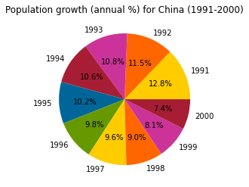

*Fig 4: China’s population growth over 10 years*

There were many policies that have been implemented and many measures taken to control its population because of which we can see a decrease in the annual population growth % from 1991 to 2000. There has been a significant change in just these 10 years.

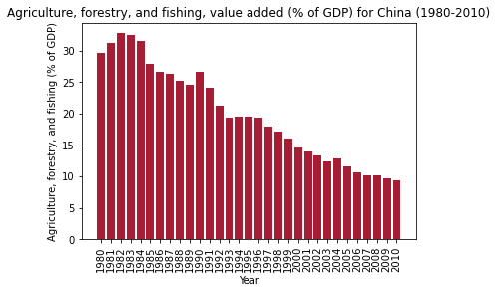

*Fig 5: Agriculture, forestry, and fishing, value added (% of GDP) of China*

The above graph shows that as China's population grew during this period, the contribution of the AFF sector to the country's GDP experienced a decline. This decrease in curve is primarily driven by the rapid expansion of other sectors, such as manufacturing, construction, and services, which absorbed a larger share of economic activity.

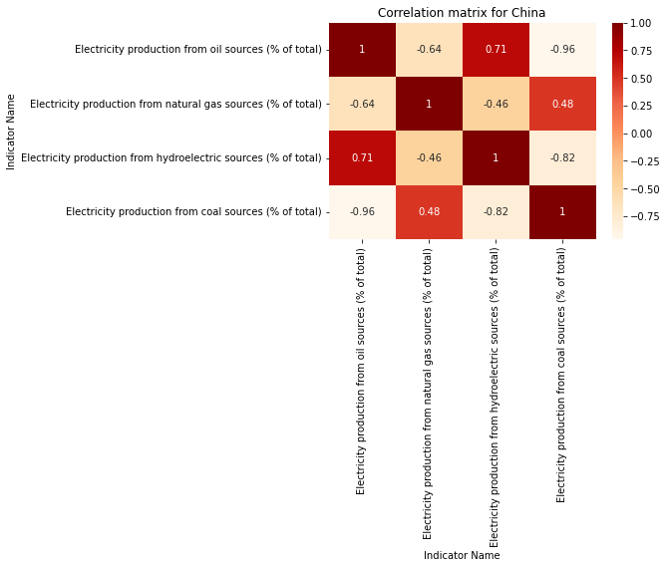

*Fig 6: Electricity production Heatmap of China*

China produces electricity from different sources, including oil, natural gas, hydroelectric, and coal. China's rapid economic growth and increasing energy demand have given rise to the need for expanded electricity production. As a result, more coal-fired power plants were built to meet the rising energy requirements. In the same manner, an increased share of renewable energy sources like hydroelectric power shows positive correlations with these indicators.

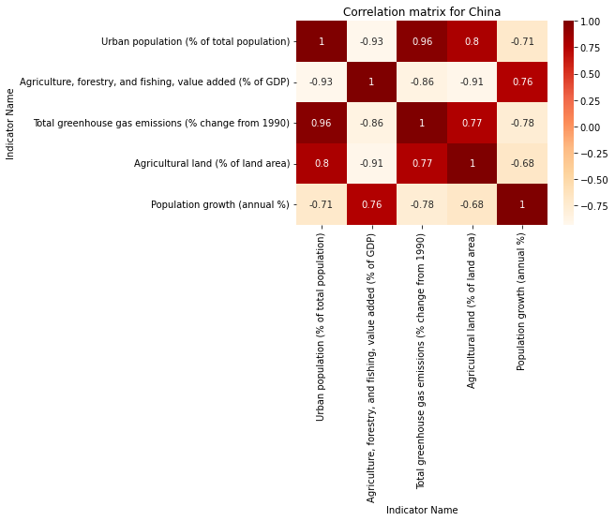

*Fig 7: Heatmap of China*

Overall, we can see how all these factors have shaped not only the socio-economy conditions but also the environmental factors. Although there is a huge shift in industrialization there is also scope for sustainable energy implementation. Comprehensive strategies that focus on sustainable development, clean energy transition, efficient resource use, and promoting environmentally conscious behaviors, are slowly being applied to tackle climate change.